# Objectives

* + You will configure and test Remote Desktop, install **Remote Server Administration Tools for Windows 10** and configure PowerShell for remote access.

## Skills Reviewed

* + Allow apps through Windows Firewall.
  + Granting users rights inside apps.
  + Use IPCONFIG.
  + Change startup type of Windows service.

## New Skills

* + Install **Remote Server Administration Tools for Windows 10** (**RSAT)** using dism.

# Initial Conditions

The following guided practices are complete:

* + Corporate network setup (Domain needed).
  + Install Windows 10 (CLIENT2 needed).
  + Upgrade to Windows 10 (CLIENT1 needed).
  + User accounts (user Master Chief and Larry Bell accounts).

# Final Conditions

At the end of this exercise, you will have:

* + **Remote Desktop** enabled on **CLIENT2**.
  + RSAT installed on **CLIENT2.**
  + Remote Power shell enabled on **CLIENT1** and **CLIENT2**.

# Instructions

1. Log into **CLIENT2** using your administrative account.
2. Enable **Remote Desktop.**
   * 1. Open **System** and click **Remote Desktop**.
        1. **Remote Desktop** opens**.** Click **Enable Remote Desktop.** Click **Confirm** to confirm. It should show **On** now.

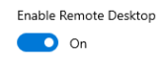

1. Test **Remote Desktop** access to **CLIENT2.**
   * 1. Do not log out of **CLIENT2**, login to **CLIENT1** as **Master Chief**.
     2. Open **Remote Desktop Connection** (**Start** > **Windows Accessories** > **Remote Desktop Connection**).
     3. **Remote Desktop Connection** opens. Enter **DE-02** computer name in the **Computer:** text box and click **Connect**.

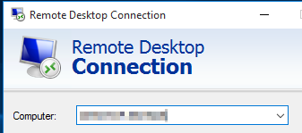

* + 1. When prompted, enter credentials for **Master Chief**.
    2. If prompted, click **Yes** to accept the digital certificate.
    3. Click **Yes** on the message indicating that another user is logged on.
    4. “Please wait…” this wait is normal and may take a couple minutes.
    5. Login to **CLIENT2** when Remote Desktop is complete. How do you know that you are accessing **CLIENT2**?
       1. Look at top of screen, you will see the **Remote Desktop** banner with the computer name in the banner.



* + - 1. Use **IPCONFIG** to verify the name of the system.
      2. Capture a snippet that shows the Remote Desktop banner and IPCONFIG output that shows the Host name and your domain name. Save the snippet as **RemoteDesktop_*studentID*.png** (where ***studentID*** is your studentID).

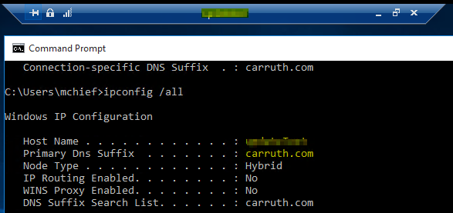

* + 1. Minimize **Remote Desktop**. You should see the **Remote Desktop** icon on the Taskbar. Verify that you are back on **CLIENT1**.



* + 1. Click the **Remote Desktop** icon. You are back on **CLIENT2**.
    2. Sign out of **Remote Desktop**. (Right click **Start**).
    3. Click on **CLIENT2** VM; you will need to reconnect. Is your administrative account still logged in? Why?
    4. Test another user. Log into **CLIENT1** as **Larry Bell**. Attempt to establish a Remote Desktop Session to **CLIENT2** as you did with **Master Chief**. Why are you unable to connect? (**Hint**: What group(s) is Master Chief in?)
    5. Enable Larry Bell to log into **CLIENT2** using **Remote Desktop**.
       1. Log into **CLIENT2** using your administrative account. Right click **Start** **-> System** and click **Remote** **Desktop**.
       2. Click the **Select users that can remotely access this PC** link.
    6. The **Remote Desktop** **users** popup opens. Click the **Add** button and add the **lbell** account. Click **OK**. Click **OK.**
    7. Log into **CLIENT1** as **Larry Bell**. Attempt to establish a **Remote Desktop** session to **CLIENT2** as you did with **Master Chief**. You should be able to this time.
    8. What local group on the **CLIENT1** computer was **Larry Bell** added to? Add **Domain Users** group to this group.
    9. Log into **CLIENT1** as **Carol Ashworth** (cashworth) and then access **CLIENT2** using Remote Desktop.
    10. Configure **CLIENT1** so that all users in the domain can access **CLIENT1** via remote desktop.

# Instructions – enable powershell remote

1. Another common method of remote management is PowerShell. Configure your computer for remote management with PowerShell as follows.
   * 1. Login to **CLIENT2** and open a **Windows PowerShell (Admin)**.
     2. Enter the command **winrm quickconfig**.
        1. Enter **Y** to start the **WinRM** service.
        2. Enter **Y** to create a **WinRM** listener and enable the firewall exception.
     3. Enable remote PowerShell management on **CLIENT1.**

# Instructions – Add Remote Server Administration Tools for Windows 10.

1. Log onto **CLIENT2**.
2. Add **Remote Server Administration Tools for Windows 10**.
   1. In **Window PowerShell (Admin)** issue the **winver** command. On the popup, note the version number.

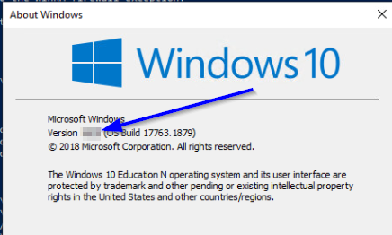

* 1. Starting with Windows 10 October 2018 Update (Build 1809), RSAT is included as a set of **Features on Demand** in Windows 10 itself. The **Remote Server Administration Tools**, RSAT, must be added using **DISM.exe**. Execute the following command to add RSAT for Active Directory

dism /online /add-capability /CapabilityName:RSAT.ActiveDirectory.DS-LDS.Tools~~~~0.0.1.0

Reference: <https://docs.microsoft.com/en-us/windows-hardware/manufacture/desktop/features-on-demand-v2--capabilities#using-dism-add-capability-to-add-or-remove-fods>

* 1. After the installation is complete, open **Active Directory Users and Computers**.
     1. **Start -> Windows System -> Windows Administrative Tools -> Active Directory Users and Computers**
     2. You should see the **KMK.local** domain in the tool.

# Document work

1. On your VMHost system, **download** the ***GP06-RemoteManagement.Test.ps1*** grading script from the assignment page to the **C:\Scripts** folder.
2. Check your lab to this point by running the following command:

Invoke-Pester -Path C:\Scripts\GP06-RemoteMangement.test.ps1 -Output Detailed

1. You should not see any red in the output. Most of the time, the output will tell you what is wrong. If it is not obvious, contact your teacher and ask for assistance. **Correct** any **errors** you may have and run the script until all the output is green as shown in the figure. You should see the output below. Capture a snippet of the **output** **from** the **script** that shows the PowerShell Command output. Save the snippets as **remote.png** for including in the report for this activity.

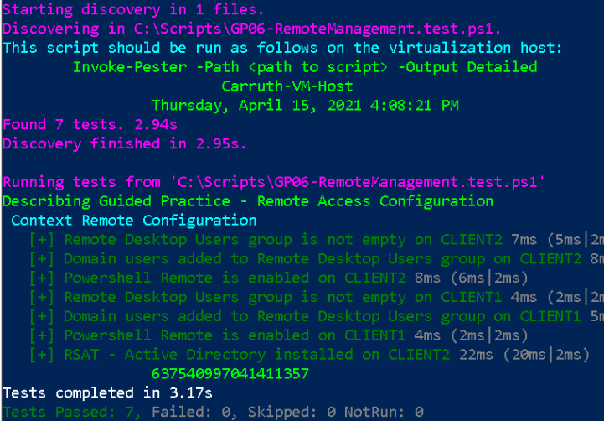

1. Add the **remote.png** image to the Guided Practice report and save the report as **Remote_*Firstname*_*LastName*.docx** where ***Firstname*** is your first name and ***Lastname*** is your last name.
2. Upload the report as the submission for this activity.